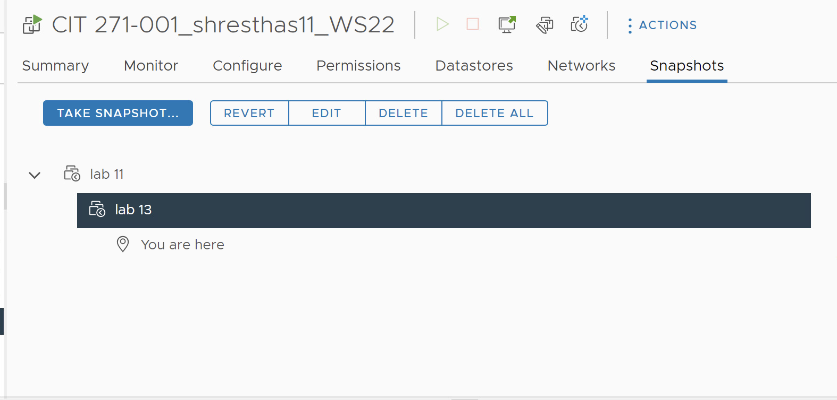

Install-WindowsFeature -Name Hyper-V -IncludeAllSubFeature -IncludeManagementTools

Restart-Computer

Get-WindowsFeature | Where-Object { $_.Name -like '*Hyper-V*' }

